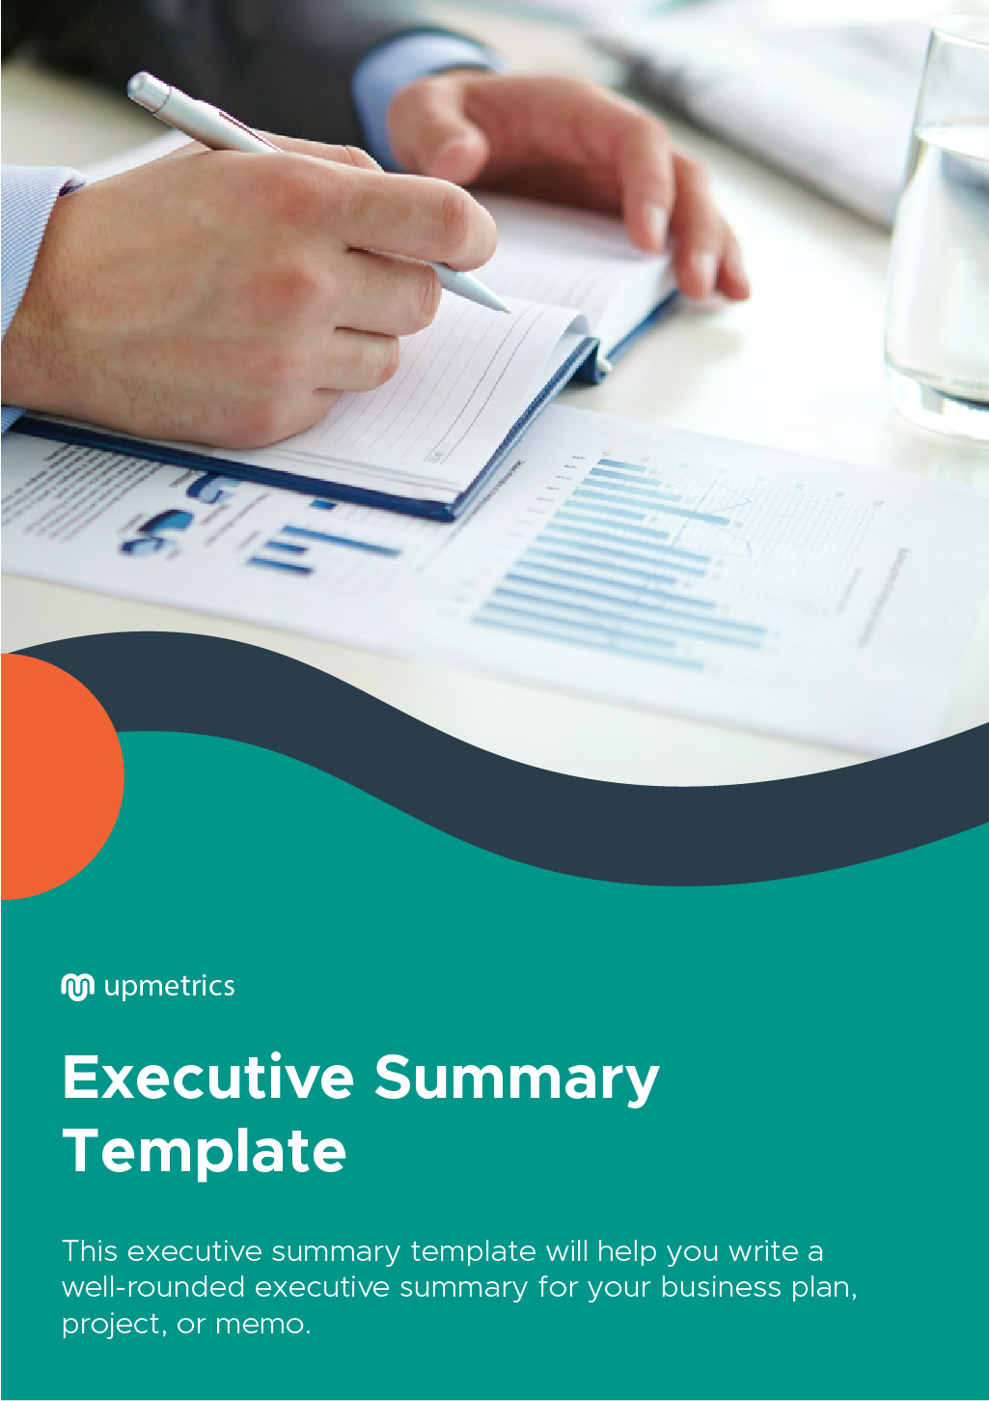

| **Hi There!**  Thanks for downloading this executive summary template.    You Can Edit This Version To Fit Your Needs. |
| --- |
| **What is executive summary?**  An executive summary serves as the first impression of your business. It provides an overview of your plan in a clear and precise manner.  It mainly serves two purposes:   1. It helps you explain your idea to the stakeholders of your business in a short time. 2. It helps you convince investors who do not have the time to read your entire business plan.   An executive summary sums up all the major sections of your business plan, but should not exceed one or two pages. Whatever you write in an executive summary should be short precise and to the point.  And although an executive summary forms the first page of your document, it should be written towards the very end to help you sum up your idea clearly. |

| Do you want to plan your business faster?  Upmetrics can help you at every step of writing your business plan.  So, what are you waiting for! | Sample Business Plan |
| --- | --- |
| [**Start writing your business plan today**](https://upmetrics.co/call-to-download?utm_source=executive-summary&utm_medium=create-business-plan&utm_campaign=download&discount=WELCOME-10)**!** | |

**Introduction**

| Introduction should give an idea of what you are going to talk about. Your introduction should be gripping. It should make your reader go further.  For an executive summary, your introduction should act as a preamble to what you’ll  Want to explain throughout the course of the document. Apart from that, it should  Also help your reader understand what questions the document would answer.  ***Upmetrics Tip:*** *Don’t take up more than two paragraphs to give an introduction,*  *Keep it brief.* |
| --- |

**Business Objectives**

| This section would consist the primary purpose of your business. It would describe the purpose your business serves, its position in the market, the market segment it caters to, and so on.  This section explains to your readers why your business idea is a good and useful one.  It also helps your investors decide whether they would like to support your idea or not.  So, make sure that you are as clear and direct with your objective as possible.  ***Upmetrics Tip:*** *Try to add a consumer pain point that your business solves and*  *How it solves it, to make your business objective look more relatable.* |
| --- |

**Company Profile**

| This section would consist of details about your organization. It includes the size of your team, your products and services, your business model, the roles and responsibilities of your team members, etc.  It helps a reader understand what you do, and what your business has in store for customers and investors.  ***Upmetrics Tip:*** *Take help from your team while writing this section to ensure that*  *you don’t miss out on important things or include unnecessary details.* |
| --- |

**Market Analysis Summary**

| Mention a brief summary of your market analysis in this section. List out everything ranging from market trends, market segments and where your product or service fit in the market. This section helps in explaining where your product fits in the market.  ***Upmetrics Tip:*** *Include all the points that can potentially help you convince*  *Your investors about your business idea.* |
| --- |

**Marketing Summary**

| This segment would consist of the main points of your marketing strategy. Include how you plan on gaining more market share or penetrating an existing market further.  Include what are your goals and targets, as well as how you would advertise your product or service.  ***Upmetrics Tip:*** *Back your strategies with facts to make it look more convincing.* |
| --- |

**Operations Summary**

| This section would consist of your daily business activities and milestones you plan on achieving with your business.  This explains what an average day at your company would look like.  ***Upmetrics Tip:*** *Put an emphasis on your business milestones, and keep them realistic.* |
| --- |

**Financial Summary**

| This section consists of your financial plan. Your cash flow, profit, and balance sheet projections, as well as details about your revenue stream.  This section should help your investor understand how you plan on providing  Returns on their investment.  ***Upmetrics Tip:*** *Include key metrics and the crucial data that is of interest to*  *Your investors in this section.* |
| --- |

**Conclusion**

| Sum up all that you described in your executive summary and give a brief overview of what you are going to talk about in your plan later on.  The executive summary helps you explain your business idea in less than 10 minutes. It serves as a pitch to your investors. So, use your words as wisely as possible.  Moreover, it is always a good practice to take suggestions from your team to ensure that you don’t miss out on crucial information. Moreover, you can also get it checked by your friends before you present it to your investors to ensure that an outsider can understand your business idea properly through your executive summary. |
| --- |