2.1 Sustainable Model Canvas Template and Step-by-Step Guide (Source: Sustainable Business Model Canvas | Threebility)
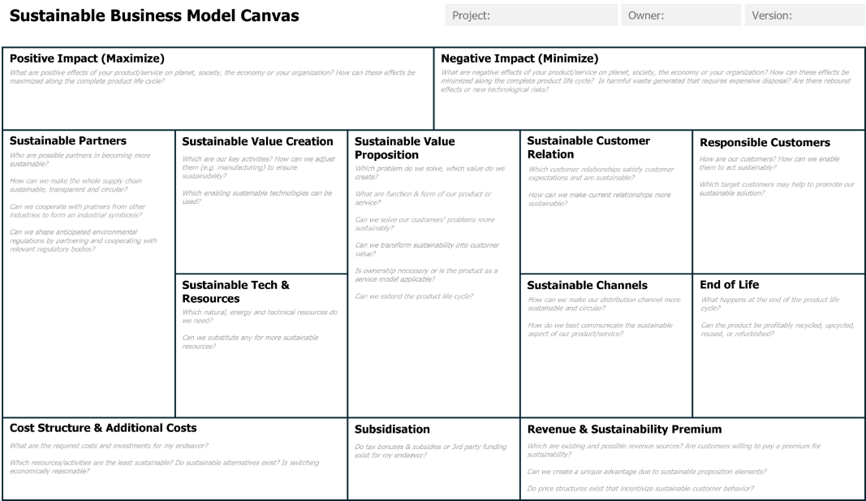

Go through each part of the Sustainable Business Model Canvas and try to identify the different parts by answering the questions on the canvas.
The guiding questions below will also support you in the answering process. Identify the areas where your business can have the most significant impact. Regularly revisit and refine the canvas as your business evolves. Use the completed sustainable business model canvas to communicate your sustainable business plan to stakeholders, including private equity investors.

- Positive Impact (Maximize)
Identify the ways your business creates positive environmental and social impacts.
- How does your business contribute to environmental sustainability (e.g. renewable energy use, carbon sequestration)?
- What positive social outcomes does your business create (e.g. equitable job opportunities, improved community well-being)?
- How can these impacts be scaled or maximized over time?

- Negative Impact (Minimize)
Assess and reduce the environmental and social harm caused by your operations.
- What are the key environmental impacts of your business (e.g. emissions, waste, resource depletion)?
- How can you reduce or eliminate these impacts (e.g. process optimization, material substitution)?
- What social risks or harms might your business pose, and how can they be mitigated?

- Sustainable Partners
Identify external organizations or stakeholders essential to your business.
- Which partnerships (e.g. suppliers, NGOs, governments) can enhance sustainability?
- How can you collaborate to reduce environmental impacts or increase social benefits?
- Are your partners aligned with your values and goals?

- Sustainable Value Creation
Focus on processes and activities that drive sustainable value throughout your value.
- What sustainable practices are embedded in your production and delivery processes?
- How do you ensure ethical labor practices and environmental responsibility across the value chain?
- Are there opportunities to innovate for greater sustainability?

- Sustainable Value Proposition
Define the unique value your business delivers to customers while addressing environmental and social impacts.
- What problem are you solving for your customers?
- How does your product/service contribute to environmental sustainability?
- How does your product/service benefit society or create social value?

- Sustainable Customer Relationships
Outline how you build and maintain relationships with your customers.
- How do you build trust through transparency about your sustainability practices?
- What methods (e.g. loyalty programs, education initiatives) support long-term customer engagement?
- How do empower customers to be part of your sustainability efforts?

- Responsible Customers
Identify the specific groups of people or organizations your business serves.
- Who are your primary and secondary customers?
- How do you address the needs of underserved or marginalized groups?
- What sustainable or ethical concerns do your customers value?

- Sustainable Tech & Resources
Define the critical assets needed to deliver your value proposition.
- What resources (e.g. material, energy) are essential, and how can they be sourced sustainably?
- Are you utilizing renewable or recycled materials?
- How do you ensure ethical labor practices in your supply chain?

- Sustainable Channels
Determine how you deliver value to your customers.
- What are the most sustainable ways to reach your customers (e.g. digital, local delivery)?
- Are you using environmentally friendly or ethical distribution methods?
- How do your channels align with your sustainability goals?

- End of Life
Plan for the responsible disposal or repurposing of your products at the end of their lifecycle.
- How do you ensure your products are recyclable, reusable or biodegradable?
- Are there systems in place for take-back or circular economy practices?
- How do you educate customers about the end-of-life options for your products?

- Revenue & Sustainability Premium
Identify how your business earns income while aligning with sustainable principles.
- What pricing models support sustainability (e.g. subscriptions, pay-per-use)?
- Are there opportunities to generate revenue through circular economy principles (e.g. recycling, reuse)?
- How do your revenue streams reflect your commitment to social and environmental value?

- Cost Structure & Additional Costs
Understand the costs of operating your business sustainably.
- What are the most significant costs, and how can they be optimized for sustainability?
- Are you investing in renewable energy, eco-friendly materials or fair labor practices?
- How do you balance profitability with sustainability investments?

- Subsidisation
Leverage financial support to offset sustainability-related costs.
- Are you eligible for government grants, subsidies or incentives for sustainable practices?
- What partnerships or collaborations can help share costs (e.g. joint ventures, co-investment)?
- How can you use subsidies to accelerate sustainability efforts?

